SOUTH CENTRAL OREGON FIRE MANAGEMENT PARTNERSHIP

BUREAU OF LAND MANAGEMENT  LAKEVIEW DISTRICT |  | U.S. FOREST SERVICE  FREMONT-WINEMA NATIONAL FOREST | OREGON DEPARTMENT OF FORESTRY  KLAMATH-LAKE DISTRICT | U.S. FISH & WILDLIFE SERVICE  SHELDON-HART MOUNTAIN and  KLAMATH BASIN  NATIONAL WILDLIFE REFUGES |  |  | NATIONAL  PARK SERVICE  CRATER LAKE  NATIONAL PARK

2021 Aerial Recon/Detection Plan

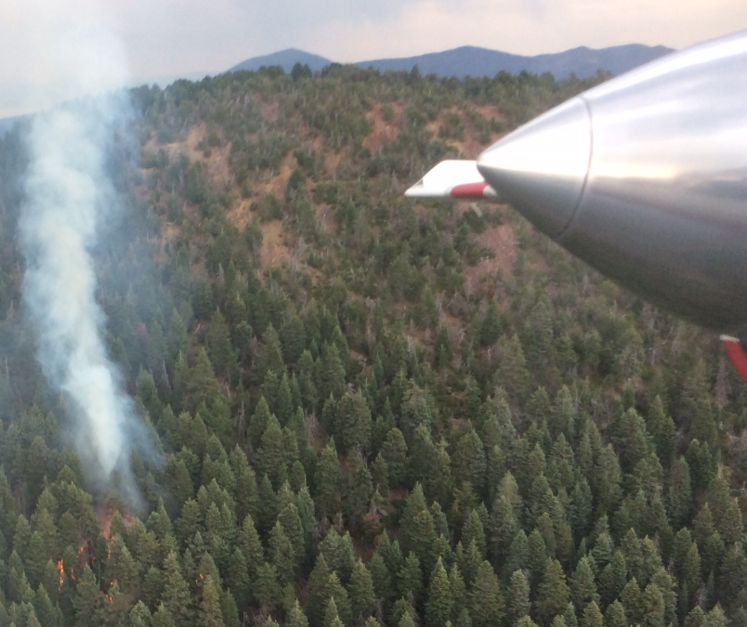
(SCOFMP)
2021
SCOFMP Aerial Recon/Detection Plan

Signatures and Approval

Prepared by: Danny Williams Date: X-XX-XXXX
Assistant UAO/ATGS
Reviewed by: _____________________________ Date: _______
Fire Staff Officer
Reviewed by: _____________________________ Date: _______
Lakeview Interagency Fire Center
Approved by: _____________________________ Date: _______
Unit Aviation Officer

Table of Contents
Introduction 4
Objectives
Scope
Review/Revision
Responsibilities
Locations
Organization and Agency Responsibilities 5
Organization
Agency Responsibilities
Personnel Qualifications
Safety 5
General
Aerial Hazard Maps
Aviation Mishap Response Guide
Incident/Hazard/Maintenance Deficiency Reporting
Weather
Operations, Communication and Dispatch 7
Dispatch Procedures
Air to Air Communications
Air to Ground Communications
Pilot Responsibility
Aerial Observer Responsibility
Availability Period
Flight Hour and Duty Day Limitations and Days off Scheduling
Aircraft Maintenance
Introduction

Objectives
The intent of the Aerial Recon/Detection Plan is to provide guidance to and standardize procedures for Recon/Detection missions within the areas served by South Central Oregon Fire Management Partnership (SCOFMP). Copies of this document should be available for review by agency personnel and flight crews.
Scope
This operations plan is intended to apply to all Recon/Detection activities conducted within SCOFMP by agency and contract personnel.
Review and Revision
The Aerial Recon/Detection Plan will be reviewed annually by the local Unit Aviation Officer (UAO) or their designee and updated as necessary.
Responsibilities
The ordering of Aerial Observers and aircraft will be facilitated through the aircraft desk at Lakeview Interagency Fire Center (LIFC). The local UAO is responsible for the overall supervision and guidance of the Aerial Observer program.
Locations
The primary bases of operation are the Lakeview SEAT/Helitack base at the Lake County Airport (LKV) (Lakeview, OR) and the Crater Lake-Klamath Regional Airport (LMT) (Klamath Falls, OR). Recon/Detection aircraft may also be ordered or initiated from other locations depending upon needs or availability. For example: If local helicopter is staged at Fort Rock, it may be used as recon and initiated from that location. Orders may also be placed with neighboring units depending on availability.

Organization and Responsibilities
Organization
The UAO or designee will oversee the unit Recon/Detection program.
Agency Responsibility
Agency and contract aircraft may be utilized. All aircraft and pilots must be approved and carded for aerial reconnaissance. SCOFMP will use qualified aerial observers and trainees may be used if accompanied with a qualified observer.
Cooperator Aircraft Letters Of Approvals
Cooperating agency aircraft must be formally pre-approved by the Regional Aviation Officer (RAO) and an approval letter must be onboard the cooperating aircraft. On the SCOFMP unit this commonly applies but not limited to the Oregon Department of Forestry (ODF) fixed-wing and helicopters. Any needed inspection/approvals (of aircraft and/or pilots) will be coordinated by the SCOFMP UAO through the RAO.
Personnel Qualification
Qualified Aerial Observers (AOBS) personnel are available in the Interagency Resource Ordering Capability (IROC) and local districts. All SCOFMP qualified AOBS personnel shall adhere to the required training as stated in the 310-1 and FS Fire & Aviation Qualification Guide (FSFAQG), and will have the position listed in their Incident Qualification and Certification System (IQCS) red card. It is desired that personnel who regularly perform as an AOBS pursue Interagency Aviation Training (IAT) courses required for “Fixed-Wing Flight Manager (FWFM) - Special Use”. If an AOBS is not FWFM – Special Use qualified, one will need to be present to facilitate the pre-flight briefing.
For mobilization off unit, it is required that the aerial observer have been or presently qualified as ICT5.
Safety
General
All crewmembers of each flight leg are to obtain an aircraft briefing from the pilot prior to any flight operations.
Personal Protective Equipment (PPE) requirements for all crewmembers of each flight include leather or nomex shoes, full length cotton or nomex pants and cotton or nomex shirt. A flight suit is and acceptable substitute for pants and shirt.
Aircraft engines must be shut down and propellers stopped visually before passenger loading and unloading.
Remain clear of the aircraft during fueling.
Personnel aboard the aircraft will be limited to those considered essential to the mission.
Aerial Hazard Maps
Current Aviation Hazard Maps Does that need to be capitalized? will be posted for viewing. In addition these maps will also be posted at LIFC dispatch office and all aviation bases within the SCOFMP. Hard copies of the current Hazard Map may be acquired from the local UAO, Air Tactical Group Supervisor (ATGS) and LIFC dispatch. Electronic PDF versions of the current maps are available. Contents of the Aviation Hazard Map will include but not limited to the following:
- Military Training Routes and Operating Area’s (MTR’s/MOA’s)
- Primary power transmission lines
- Microwave and wind turbine tower sites
- Significantly high bridges or misc. towers
- Aerial logging and /or high line cable operations
Region 6 Aviation Hazard Maps: https://www.fs.fed.us/r6/fire/aviation-hazards/
Incident/Hazards/Maintenance Deficiency Reporting
Incidents, accidents, flight hazards or in-flight maintenance deficiencies should be reported using the SAFECOM system. Personnel may submit reports directly to www.safecom.gov, or report relevant facts to the UAO or designee for assistance in submission.
Weather
The Aerial Observer and pilot will review and discuss weather forecasts daily and prior to all flights. Encourage pilot to give feedback on the forecasted weather pertaining to the mission and if there are any concerns. Be alert to changing or rapidly developing conditions. Any adverse weather such as but not limited to, thunderstorms, mountain waves, compromised visibility etc. may require modification or termination of flights/mission. Communicate those decisions and rational to LIFC. The pilot has the final say on all flights and air crews will be supported in any decision to terminate a flight based upon these hazards.
Operations, Communication and Dispatch
Fire detection and reconnaissance flights may be made with either fixed or rotor wing aircraft and shall remain above 500 feet AGL except during takeoffs and landings.
Dispatch/Flight Request Procedure
Dispatch and the UAO will coordinate/prioritize aerial detection needs primarily based on a flight by flight “request” basis from unit Duty Officers (DO). Flight Managers (AOBS), may be assigned by the requesting DO directly, or coordinated by dispatch from local availability lists. It is desired that whenever possible requests for recon be communicated to dispatch by 1800 the day prior to the flight needed. It is generally understood that lightning and weather events may not allow for the prediction of a need for recon by this time. An effort to request a mission as early as possible will increase the ability to ensure that mission can be achieved.
Recon Types – Lightning and General
A recon may be requested by duty officers DO for various reasons. Most commonly will be due to current lightning or lightning that occurred the previous day/days prior to the request. It is not uncommon to recon lightning areas where lightning occurred 3 or 4 days in the past. This may be determined by the amount of hold over fires that are being reported, weather or fire danger. General or specific recons may also be requested due to high fire danger, frequent occurrences of human caused fires, heavy recreational activity in specific areas, etc.
Lightning recons will occur at the request of DO’s and will primarily focus on areas that received lightning. Areas/routes and times for these recons will need to be provided by the requestor. The amount of direction and information needed for the observer will depend on his/hers local knowledge of the area. If the observer does not have access to the lightning map or does not possess a mobile device with local map capabilities, paper maps and specific Lat/Longs may be needed. Requesting DO’s will be responsible for providing this information to the observer, however dispatch, UAO or ATGS/Asst. UAO can assist with providing information.
General recons, as stated above, may be requested due to high fire danger, frequent occurrences of human caused fires, heavy recreational activity in specific areas, etc. SCOFMP has developed general recon routes to facilitate this type of recon. A map titled “SCOFMP General Recon Routes” is located on page 15 of this plan. Due the size of the zone, it is separated into 3 areas of manageable recon routes. Each route is numbered in segments and on page 16 of this plan are lat/longs associated with each numbered segment of each route. The PDF/GEO referenced map is also available for use with a mobile device in which the lat/longs can be determined from this map. For observers who do not possess a mobile device capable of using PDF maps, the list of lat/longs will need to be provided. Each route begins with segment 1 and ends in a greater value. Starting point and direction of the route may vary depending on specific needs and originating location of the recon platform. An example would be: the Klamath Falls ATGS is requested to do a general recon of the north route, it may be efficient to begin at segment number 2 and complete the route ending at number 2. Another example: For the west route, a recon originating from Klamath Falls would likely start with segment number 1 and work around the route. If this same recon was to originate from Central Oregon, it would be more efficient to begin at segment number 9. A request to complete all or parts of these routes may vary depending on local need, weather, availability and time.
Briefing and Orientation
A tactical aviation resource order (TARO) with pertinent mission information will be provided by LIFC for requested recon missions as needed. Aerial Observers and pilots will obtain a briefing from dispatch, by phone or in person, about the intended mission including the following information:
Routes to be flown
Areas of concern
Ongoing incidents – local and neighbors
Temporary Flight Restrictions (TFR’s)
Frequencies
Forecasted weather
De-confliction of airspace (agency and military A/C)
Routes of aviation resources from bases to ongoing incidents
Recent lightning maps and data for iPad may also be provided

Airspace Coordination
Flight routing will be pre-planned with the duty officers and dispatch. The AOBS is expected to assist with “See and Avoid” and actively assist with time critical risk assessments and decision making Crew Resource Management – (CRM) as aircrew members. Dispatch will provide observers with airspace de-confliction information. Special use airspace including Military Operating Areas (MOA’s) and Military Training Routes (MTR’s) overlie much of the SCOFMP area. An understanding of the daily status of this airspace will contribute to the safety of missions.
AOBS missions must not enter into a TFR unless directly authorized by the resource managing the TFR.
Aerial Observers should be aware of their locations at all times and not deviate outside the SCOFMP unit boundary without orders/permissions from both LIFC and neighboring unit. Confirmation of communication with neighboring units must be established prior to entering their jurisdiction.
Flight Following
In-flight communication with LIFC is generally made on a “local flight following” frequency (167.1750 RX/TX) rather than national flight following. Local flight following (LFF) will be the primary frequency however it is required that all agency/contract aircraft also monitor “Air Guard” (168.6250 RX/TX tone 110.9tx) at all times. If the aircraft being utilized for the mission has the radio capacity, it is also recommended to monitor A/A and A/G frequencies. A frequency list for SCOFMP is attached to this plan.
An initial radio check with LIFC (Call sign: Lakeview Dispatch) should be done prior to taxi. Initial contact after departure, in the following order, should include:
- Call Sign
- Departure location
- Number on board
- Fuel on board
- Estimated time en route (ETE)
- Destination
- Confirm AFF
Notify dispatch when a mission is complete, destination returning to, and flight time. After landing, notify dispatch to close out the flight.
Agency/contract aircraft are equipped with Automated Flight Following (AFF). If AFF is not working or unavailable the mission must utilize 15 minute location reporting on flight following frequency with LIFC. This does not require the cancelation of a mission. AFF issues should be resolved as soon as possible per contract requirement.
If at any time radio communication is not working, the mission must stop and return to nearest/safest or home base if that can be done safely. In this case the pilot should attempt to establish FAA flight following or contact with airport control tower to return to base. Do not return to operations until radio communication has been restored and Aviation Maintenance Inspector AMI approved back to contract availability.
Observers should be aware of other incidents that may be utilizing the same frequencies. Use good radio etiquette to try to prevent interfering with ongoing critical traffic from other incidents.
Incident Reporting and Size-up
Incidents should be reported using the standard format utilized by SCOFMP if possible. A size up form is located on page 17. Initial reports will be broadcast over the local command repeater frequency to provide useful information to responding units. However during periods of multiple ongoing incidents, the volume of radio traffic may not allow for this at which time Local FF may need to be used for size-ups. Dispatch can help with this determinations/direction when radio traffic becomes overloaded. Observers should exercise flexibility and discretion using other frequencies, or delaying reporting of lower priority incidents until radio traffic permits. Size-ups for lower priority fires can be or may be limited to critical information only during these periods.
Air to Air Communications (Frequency list attached)
AM only. When possible A/A 01 OR04 or otherwise designated by dispatch should be monitored.
Air to Ground Communications (Frequency list attached)
FM only. When possible A/G 41 or otherwise designated by dispatch should be monitored. Radio limitation may prohibit this depending on the aircraft. However A/G frequencies should be programmed or available to be programmed if requested to communicate with ground resources.

Pilot Responsibility
The pilot has final authority on the operation of the aircraft and is expected to terminate any operation deemed unsafe. Pilots will be supported for terminating a flight due to safety concerns.
The pilot is responsible for:
- Safe operation of the aircraft.
- Altering intended flight routes to avoid weather, terrain, or other flight hazards.
- Terminating the flight if safety is compromised due to flight/weather conditions, mechanical issues, condition of personnel, etc.
- Aircraft maintenance. Maintenance scheduling will be conducted with as much notice to the aerial observer and LIFC as possible. It is recognized that there will be unscheduled maintenance. The aerial observer should notify LIFC of any change in availability status.
- The pilot will be responsible for all fueling operation and be present during those operations.
Aerial Observer Responsibility
The aerial observer or FWFM is responsible for the overall operation and ensuring adherence to agency policy, as well as the following:
Maintain the Daily Diary, recording all flight activity, pilot duty times, extended standby, etc.
Completion of IBS or AMD-23 Aircraft Use Report. If this is not possible observer shall at a minimum provide information to the UAO or designee that can input flight data. It is preferred that all documentation is completed on a daily basis.
Reporting accidents, incidents, incidents with potential or maintenance deficiencies consistent with SAFECOM reporting procedures.
Work with AMI on maintenance issues for returning to contract availability. (See p. 13)
Performing those duties outlined in the daily checklist. Daily checklist are attached to this plan.
Availability
Duty day will be determined by dispatch in coordination with duty officers, UAO or designee. Local fire/lightning activity or fire severity may dictate extended duty hours, with payment for standby made according to contract/agreement specifications. Aerial Observers will communicate with dispatch to confirm end of duty day time before end of shift.

Flight Hour and Duty Day Limitation and Days off Scheduling
The aerial observer shall ensure that pilots adhere to flight hour and duty day limitations as outlined in FSH 5709.16 ch.11.27a shown below:
1. All flight crewmembers flying Forest Service missions are limited to the following tours of duty, and all work-related time must count toward these limitations:
a. Duty includes flight time, ground duty of any kind, and standby or alert status at any location. This restriction does not include “on-call'' status outside of any required rest or off-duty periods.
b. Flight time must not exceed a total of 8 hours per duty day.
c. Assigned duty of any kind must not exceed 14 hours in any 24-hour period.
d. Flight crewmembers accumulating 36 hours of flight time in any 6 consecutive days or less are required to have the following day off. Maximum cumulative flight hours must not exceed 42 hours in any 6 consecutive days.
e. Within any 24-hour period, flight crewmembers shall have a minimum of 10 consecutive uninterrupted hours off duty immediately prior to the beginning of the next duty day.
f. During any 14-consecutive-day period, flight crewmembers shall be off duty for two 24-hour periods from the time of last duty. The 24-hour off-duty periods need not be consecutive.
Aircraft Maintenance
Pilots shall try to provide aerial observer/dispatch with as much notice as possible regarding scheduled maintenance. Unscheduled maintenance that renders the aircraft unavailable will be dealt with according to the terms of the contract. FSM 5713.4 states: “Do not return aircraft having mechanical or equipment deficiencies to service until the aircraft has been approved by an authorized aircraft inspector.” 351 DM 1.1e states: “Deficiencies which might affect the safety of flight shall be corrected prior to commencing flight”. The return to availability shall be approved by the RAG maintenance inspector.
  - If you are out of service for mechanical notify 1) Dispatch; 2) COR; 3) R6 Aviation inspector; 4) UAO. For mechanical, do not return to service until maintenance is cleared by R6 aviation inspector. This can likely be done verbally.
  - Avionics: Patrick Lunn – 541-419-6644
  - Airworthiness: Ron Wallace – 541-280-8371
Aerial Observers shall notify dispatch of any changes in aircraft status.

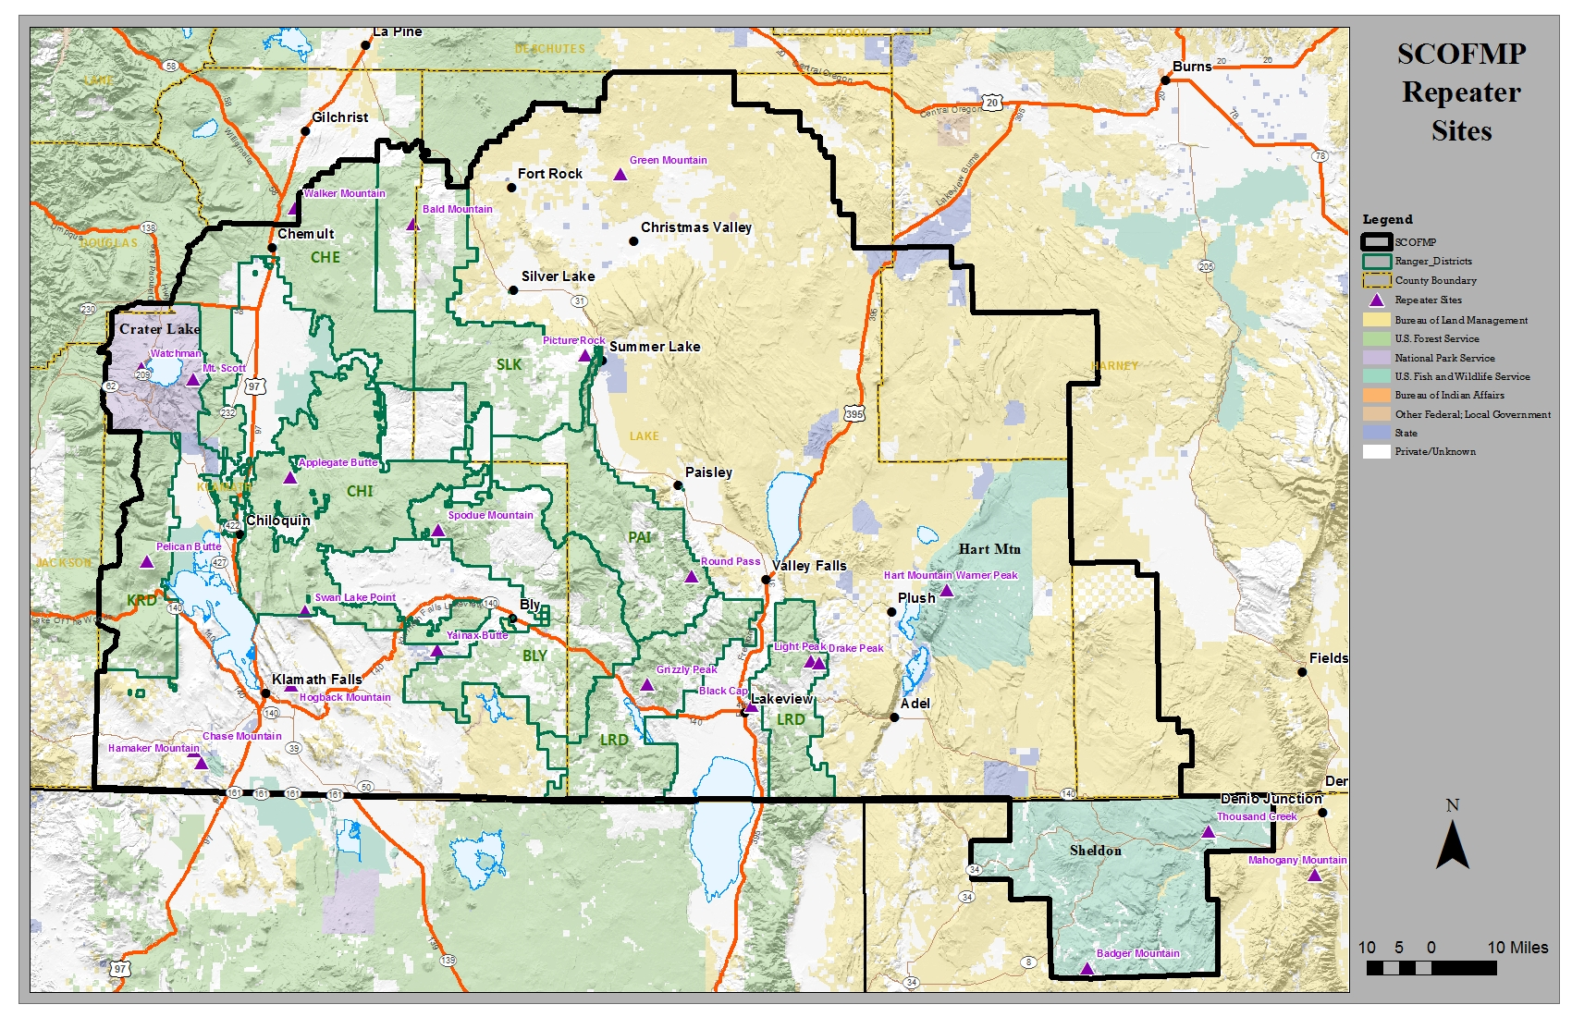
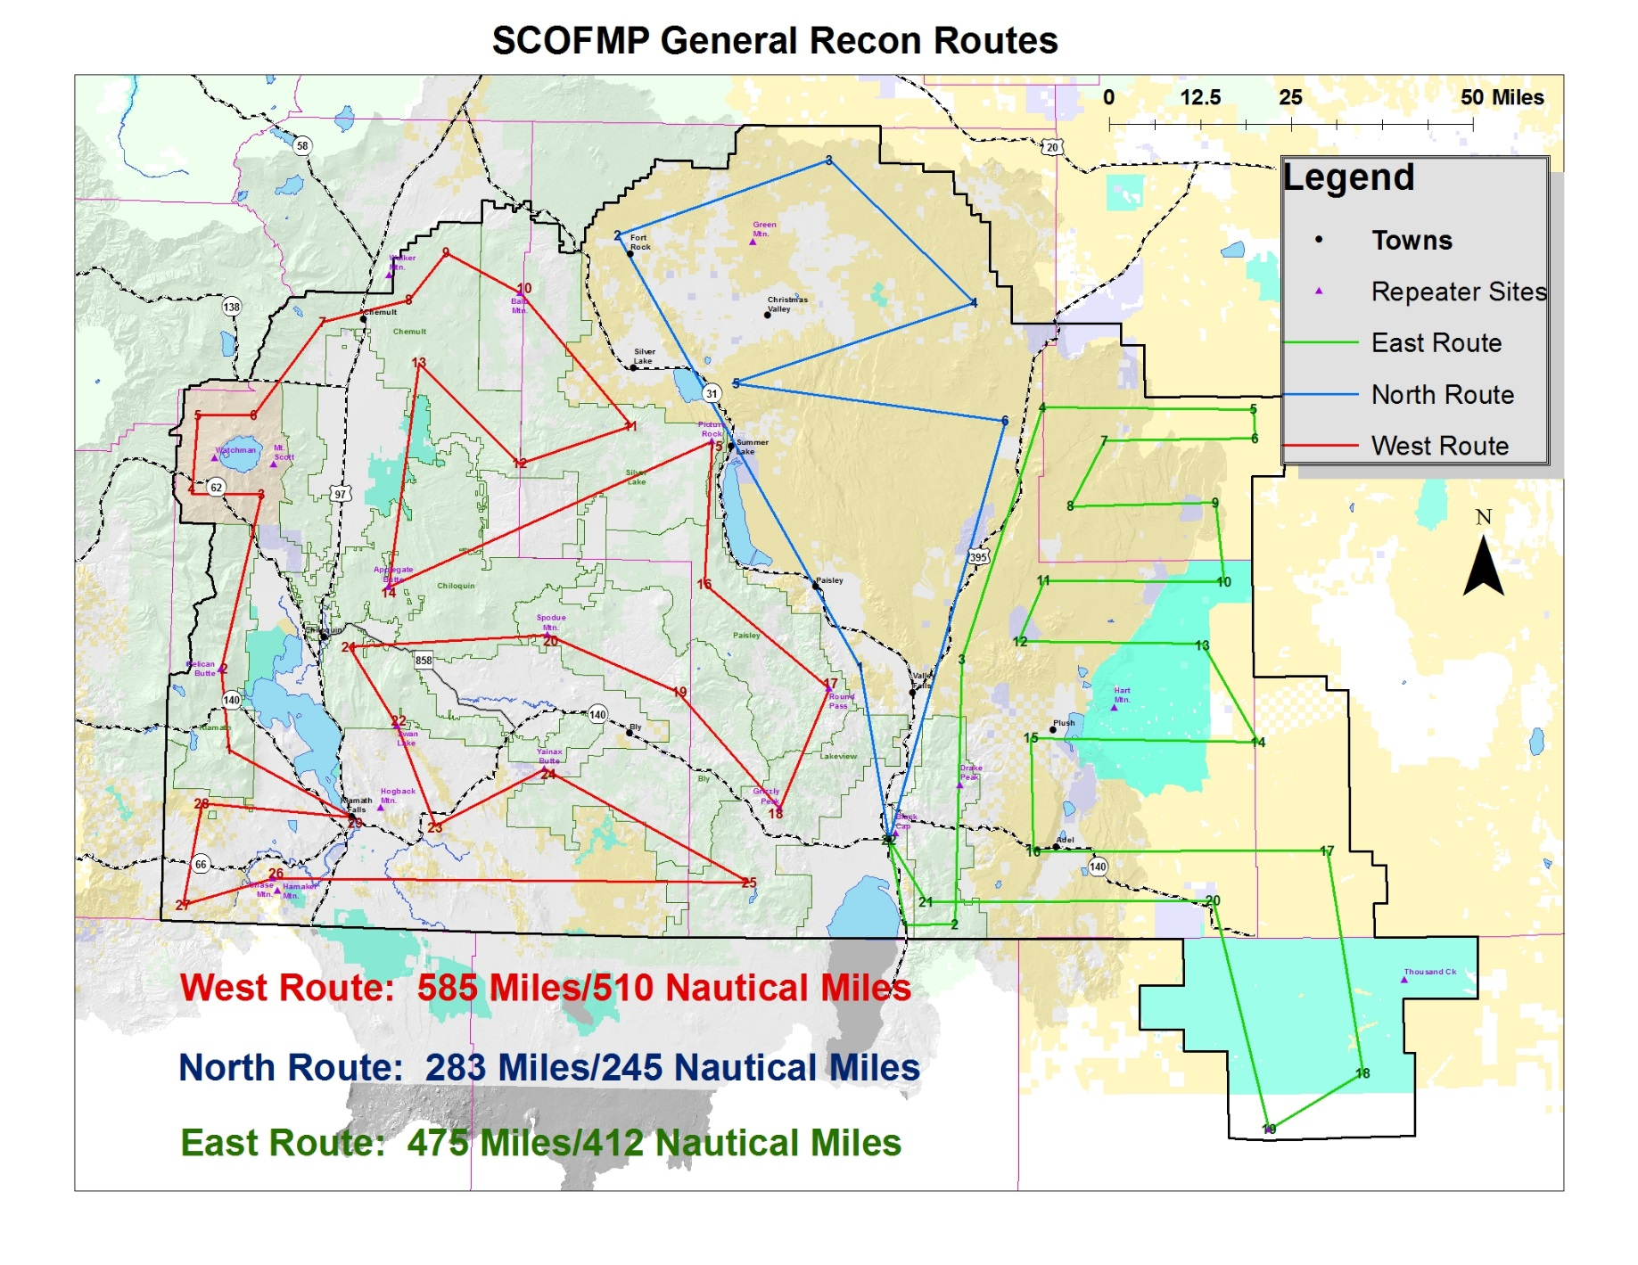
SCOFMP General Recon Route Points
West Route |  | North Route
1 | 42°21.22/122°07.10 | 1 | 42°32.19/120°25.56
2 | 42°30.54/122°08.72 | 2 | 43°23.55/121°05.44
3 | 42°51.60/122°02.97 | 3 | 43°32.75/120°31.06
4 | 42°51.41/122°14.19 | 4 | 43°15.80/120°07.31
5 | 43°00.90/122°13.55 | 5 | 43°06.07/120°46.28
6 | 43°01.16/122°04.51 | 6 | 43°01.62/120°02.11
7 | 43°12.39/121°53.69 | 7 | 42°11.51/120°20.67
8 | 43°15.36/121°39.67 | East Route
9 | 43°21.09/121°33.69 | 1 | 42°01.32/120°18.07
10 | 43°16.28/121°21.34 | 2 | 42°01.48/120°10.24
11 | 43°00.81/121°03.10 | 3 | 42°33.05/120°09.03
12 | 42°56.11/121°21.09 | 4 | 43°03.21/119°56.02
13 | 43°07.73/121°37.68 | 5 | 43°02.92/119°21.63
14 | 42°40.97/121°41.92 | 6 | 42°59.47/119°21.48
15 | 42°58.87/120°49.85 | 7 | 42°59.25/119°45.82
16 | 42°41.98/120°50.73 | 8 | 42°51.48/119°51.37
17 | 42°29.48/120°30.45 | 9 | 42°51.79/119°27.99
18 | 42°15.08/120°38.39 | 10 | 42°42.35/119°26.71
19 | 42°28.80/120°54.88 | 11 | 42°42.49/119°55.77
20 | 42°35.36/121°15.94 | 12 | 42°35.43/119°59.76
21 | 42°33.66/121°47.89 | 13 | 42°34.87/119°30.11
22 | 42°24.31/121°40.03 | 14 | 42°23.12/119°21.39
23 | 42°12.62/121°33.58 | 15 | 42°23.65/119°57.84
24 | 42°19.40/121°16.08 | 16 | 42°10.23/119°57.50
25 | 42°06.31/120°43.28 | 17 | 42°09.96/119°10.36
26 | 42°05.80/121°59.58 | 18 | 41°43.36/119°05.01
27 | 42°02.47/122°13.71 | 19 | 41°36.77/119°20.01
28 | 42°14.48/122°11.26 | 20 | 42°04.13/119°28.73
29 | 42°13.31/121°47.27 | 21 | 42°04.07/120°14.77

SOUTH CENTRAL OREGON INCIDENT ORGANIZER 2021
Initial Attack Size-Up / Risk Analysis (must be completed prior to briefing)
Date: |  | Time of Dispatch: |  |  |  |  | Arrival on Scene:
1. Fire Name: |  | Incident #: |  |  |  |  | Charge Code:
2. Incident Commander |  |  |  |  | (t) Incident Commander
3. Fire Location: (DDD° MM.MMM')  Lat: Long: T: R: Sec: |  |  |  |  |  |  |  |  | 4. Size (estimate)
5. Values at Risk: □ Houses □ T&E Species □ Water Quality □ Timber (There is always □ Improvements □ Cultural/Historical □ Public Safety □ Other (specify) a value at risk )
6. Spread Potential: □ Low □ Moderate □ High
7. Character of Fire: □ Smoldering □ Creeping □ Running □ Spotting □ Torching □ Crowning
8. Fuels Burning: □ Grass □ Brush □ Slash □ Re-prod □ Timber (light, heavy) □ Snag □ Logs □ Duff
Adjacent Fuels: □ Grass □ Brush □ Slash □ Re-prod □ Timber (light, heavy) □ Snag □ Logs □ Duff
9. Wind Speed _______ Direction _______ □ Upslope □ Up canyon □ Down slope □ Down canyon
10. Ownership:
11. Cause: □ Lightning □ Human Caused (protect origin/consider Fire Investigator) □ Other
12. Resources on Scene
13. Additional Resources Needed:
Personnel | Equipment |  |  |  |  | Supplies |  |  |  |  | Aircraft
14. Flame Length: □ < 2’ □ 2’-4’ □ 4’-8’ □ 8’-11’ □ 11’> |  |  | 15. Wind Indicators: □ Cumulus □ Lenticular □ Cold fronts □ Other |  |  |  |  |  |  | 16. Elevation:
17. Position On Slope  □ Bottom 1/3 □ Middle 1/3 □ Top 1/3 |  |  |  | 18. Percent Slope:  □0-30 □30-45 □45-60 □60> |  |  |  | 19. Aspect □ Flat ridge top  □North □East □South □West
20. Hazards (Check all that apply) □ Evacuation concerns □ Other
□ Snags □ HazMat □ Urban Interface □ Power lines □ Septic tanks □ Mine shafts
21. Any Evidence of Treatment Yes No Recent Yes No

Aerial Observer Go / No Go Checklist
Pilot and aircraft carded and current
Yes No
◻  ◻
      
Pilot within flight hour and duty day limitations

Yes No
◻  ◻
Flight equipment (headset, AOBS kit) and required PPE available

Yes No
◻  ◻
Radios programmed
Yes No
◻  ◻
Pilot briefed on mission
Yes No
◻  ◻
AOBS briefed on aircraft
Yes No
◻  ◻

Aircraft Weight and Balance calculated
Yes No
◻  ◻
Weather (current and forecast) checked and evaluated by pilot and AOBS
Yes No
◻  ◻
Flight crew briefed by dispatch about airspace deconfliction and aviation activity within unit (FTA, TFR, special events)
Yes No
◻  ◻

SCOFMP Aviation Frequencies

ZONE 11 AVIATION
CH | Description | Display | RX | Tone | TX | Tone
1 | LIFC Flight Follow Second S.E. | BADGER | 169.625 |  | 164.525 | 146.2
2 | LIFC Flight Follow Second North | BALD | 171.700 | 103.5 | 165.225 | 151.4
3 | LIFC Flight Follow Second South | SWAN | 170.600 | 103.5 | 163.6875 | 162.2
4 | LIFC Flight Follow Second North | WALKER | 170.525 | 103.5 | 162.750 | 141.3
5 | LIFC Flight Follow Second West | SPODUE | 169.925 | 103.5 | 163.375 | 162.2
6 | LIFC Flight Follow Second North | GRN MT | 173.8875 |  | 166.325 | 114.8
7 | BLM OR/WA Scene of Action | IATAC1 | 166.6375 |  | 166.6375
8 | BLM Scene of Action | IATAC3 | 166.275 |  | 166.275
9 | LIFC Local FF PRIMARY | LCL FF | 167.175 |  | 167.175
10 | OR04 Air to Ground 41 | A/G 41 | 167.475 |  | 167.475
11 | OR04 ODF Air to Ground 01 | A/G 01 | 151.310 | 156.7 | 151.310 | 156.7
12 | OR04 Air to Ground 24 | A/G 24 | 168.6375 |  | 168.6375
13 | OR03 Air to Ground 61 | A/G 61 | 169.2875 |  | 169.2875
14 | Avaition Evac EMS 28 | VMED28 | 155.340 |  | 155.340
15 | Avaition Evac EMS 29 | VMED29 | 155.3475 |  | 155.3475
16 | Air Guard | AGUARD | 168.625 |  | 168.625 | 110.9

National Flight Following: 168.6500 RX/TX tone 110.9 RX/TX
Air to Air frequencies for SCOFMP (OR04):
A/A 1 – 134.7750 | A/A 2 – 133.1250 | A/A 3 – 126.6250
Klamath Falls Tanker Base and Lakeview SEAT Base ramp: 123.9750

